**USER MANUAL**



**ONLINE RECEIPT UPLOADER**

**FOR PHINMA**

**UNIVERSITY OF PANGASINAN**

# TABLE OF CONTENTS

TABLE OF CONTENTS 2

**System Overview for Admin** 3

**Application Access for Admin** 4

**Default Admin Registration** 4

**Admin Forgot Password** 5

**Update Admin Profile** 6

**Change Admin Password** 8

**Create Student Account** 9

**Import Student Account** 10

**Print Student Record** 10

**View Student Info** 11

**Update Student Info** 11

**View Student Receipt** 12

**Verify Student Receipt** 12

**Create Staff Account** 13

**User Logs Section** 14

**Create and Set new School Year and Semester** 15

**System Overview for Student** 16

**Application Access for Student** 16

**Student Login** 16

**Update Student Profile** 17

**Change Student Password** 18

**View Paid Tuition** 19

**Upload Receipt** 19

**Payment History** 20

**System Overview for Secretary** 21

**Application Access for Secretary** 21

**Secretary Login** 21

**Update Secretary Profile** 22

**Change Secretary Password** 23

**Student List with/without Permit** 24

# **System Overview for Admin**

The Appointment System enables the Admin to perform the following functions:

* Default Admin Registration
* Retrieve Password
* Update Profile
* Change Password
* Create Student Account
* Import Student Account
* Print Student List
* View Student Info
* Update Student Profile
* View Student Receipt List
* Verify Student Receipt
* Create Admin Account
* Create Secretary Account
* View User Logs
* Create new School Year and Semester
* Set School Year and Semester

# **Application Access for Admin**

1. Open the browser and enter the URL: URL to Application
2. Press enter or Click Go
3. The Home page of the application appears as in Figure 1.1 Index Page

Figure 1.1 – Index Page

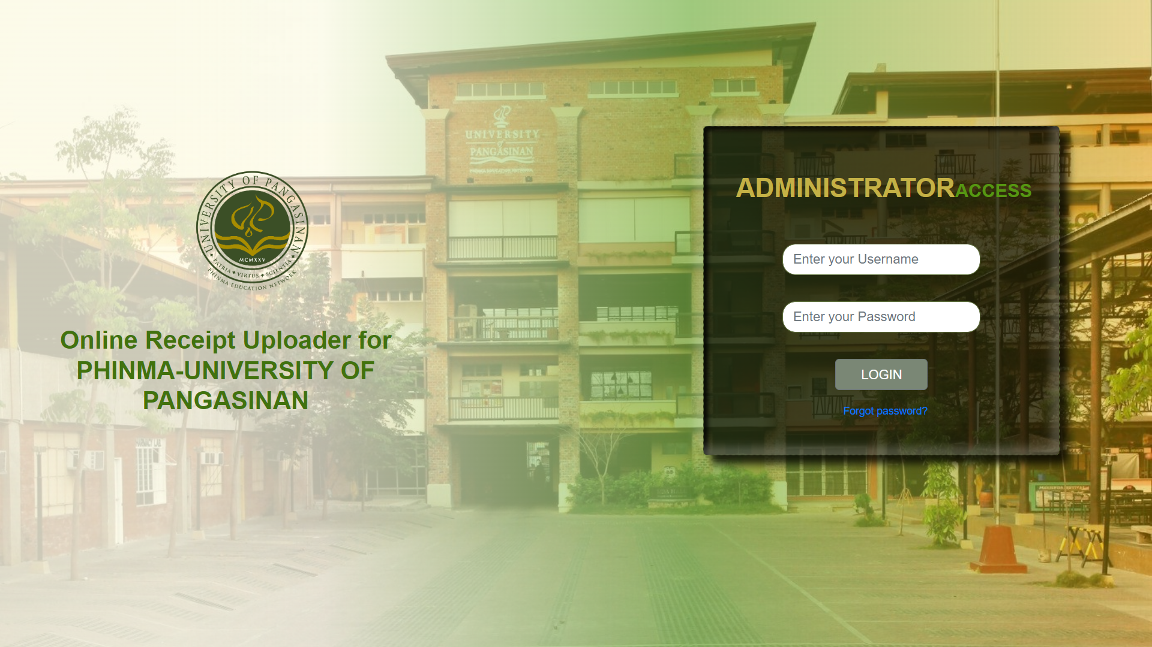

# **4. Default Admin Registration**

* Enter Admin as Username and Password for Default Admin as in Figure 1.1.

Figure 2.0 – Forgot Password Page

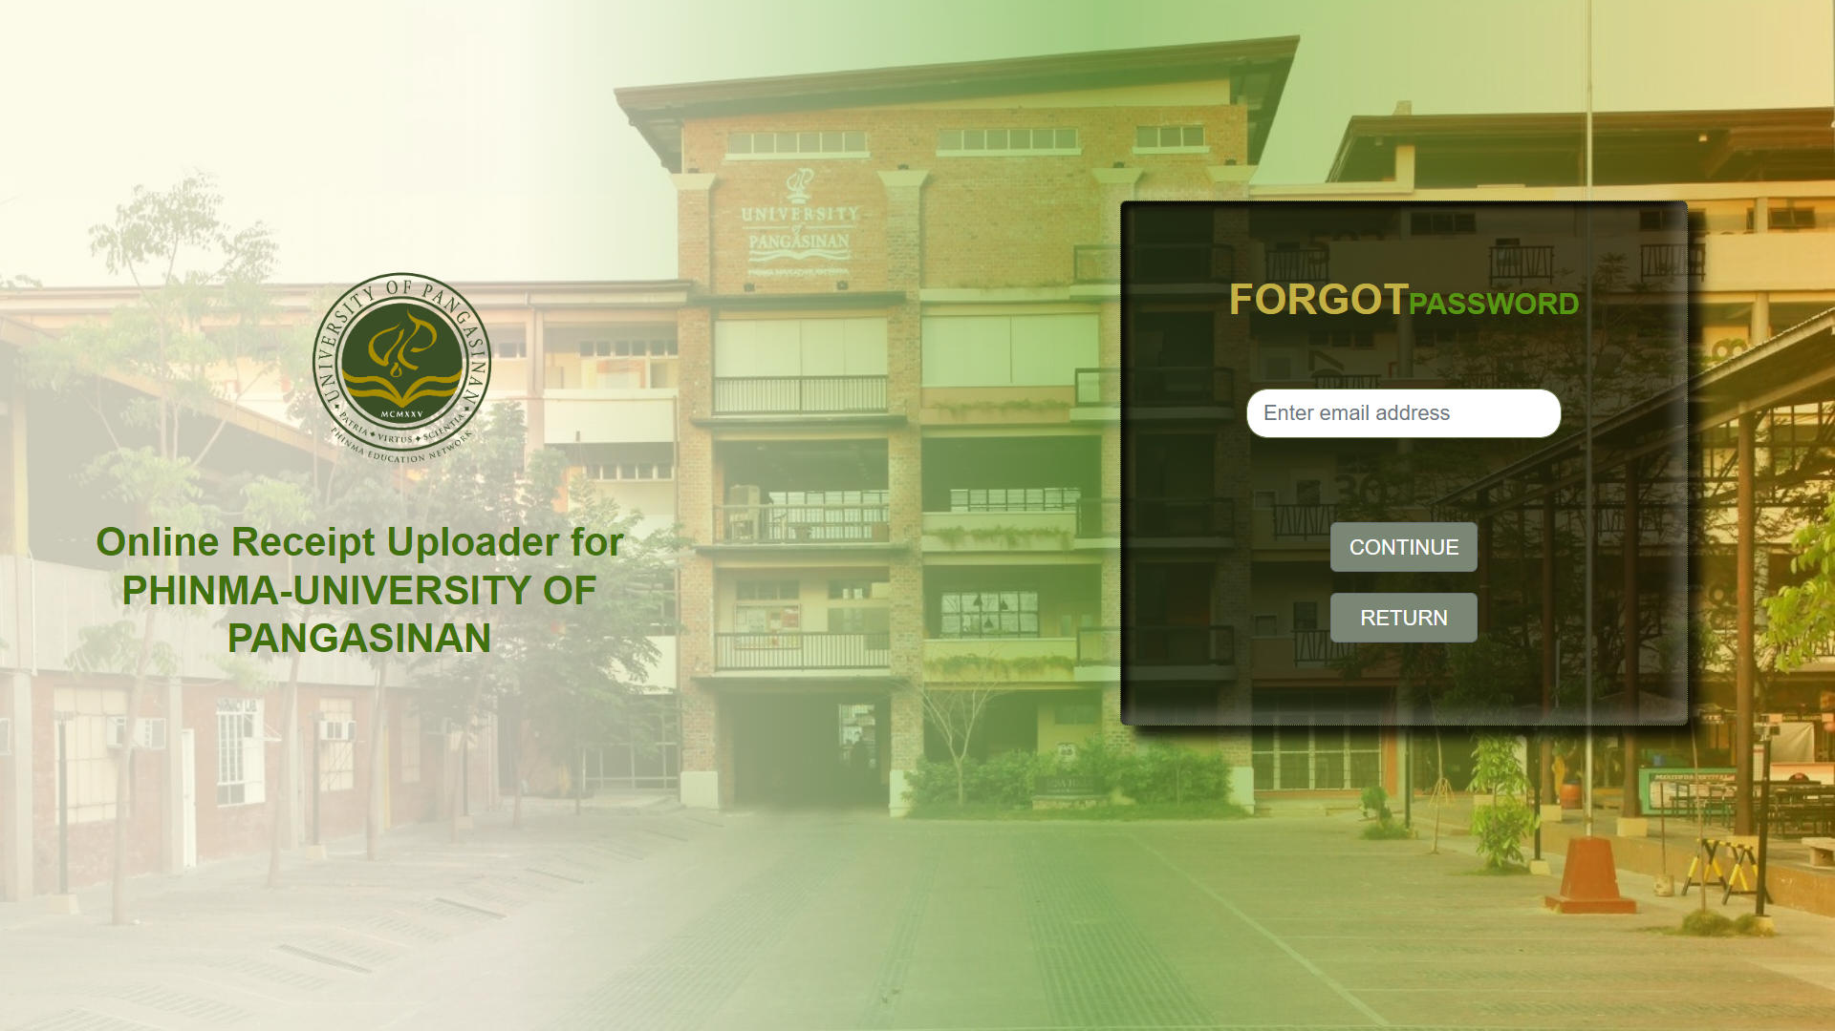

# **5. Admin Forgot Password**

* Enter your registered Email Address as in Figure 2.0 and Click Continue to receive verification code as in Figure 2.1.

Figure 2.1 – Verification Code

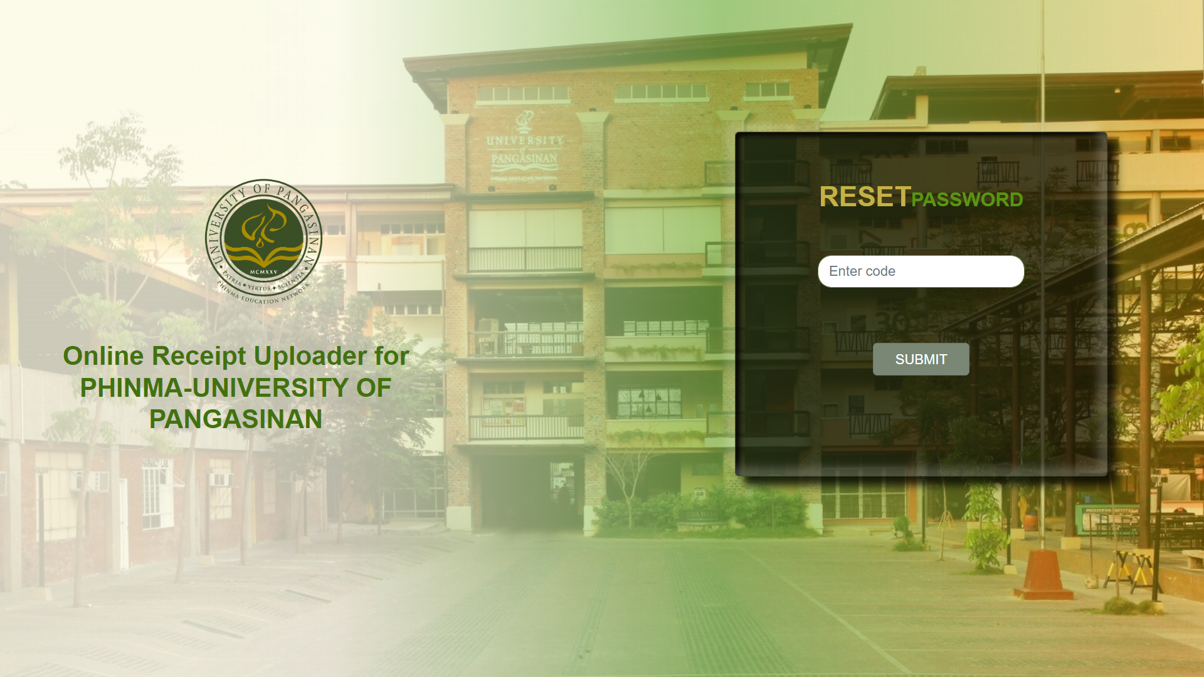

* Enter the verification code you receive at your Email as in Figure 2.1.

Figure 2.2 – New Password

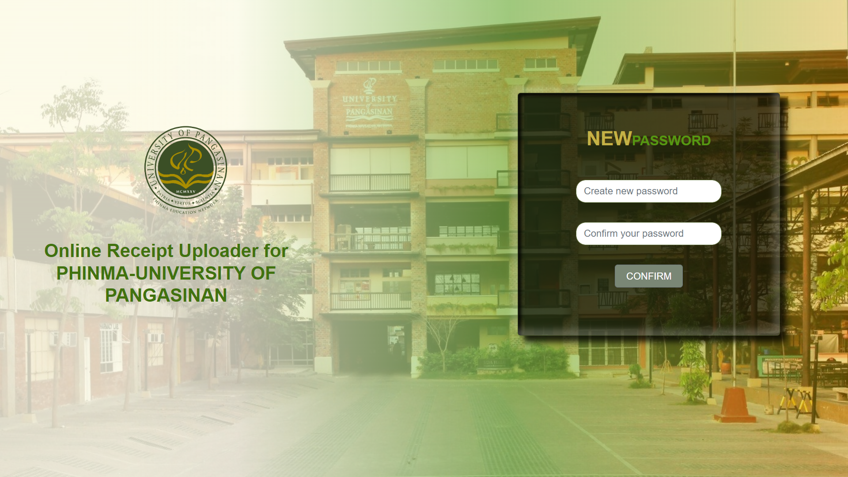

* Enter your new password as in Figure 2.2 to redirect you into Log in page as in Figure 1.1.

# **6. Update Admin Profile**

Figure 3.0 – Dashboard

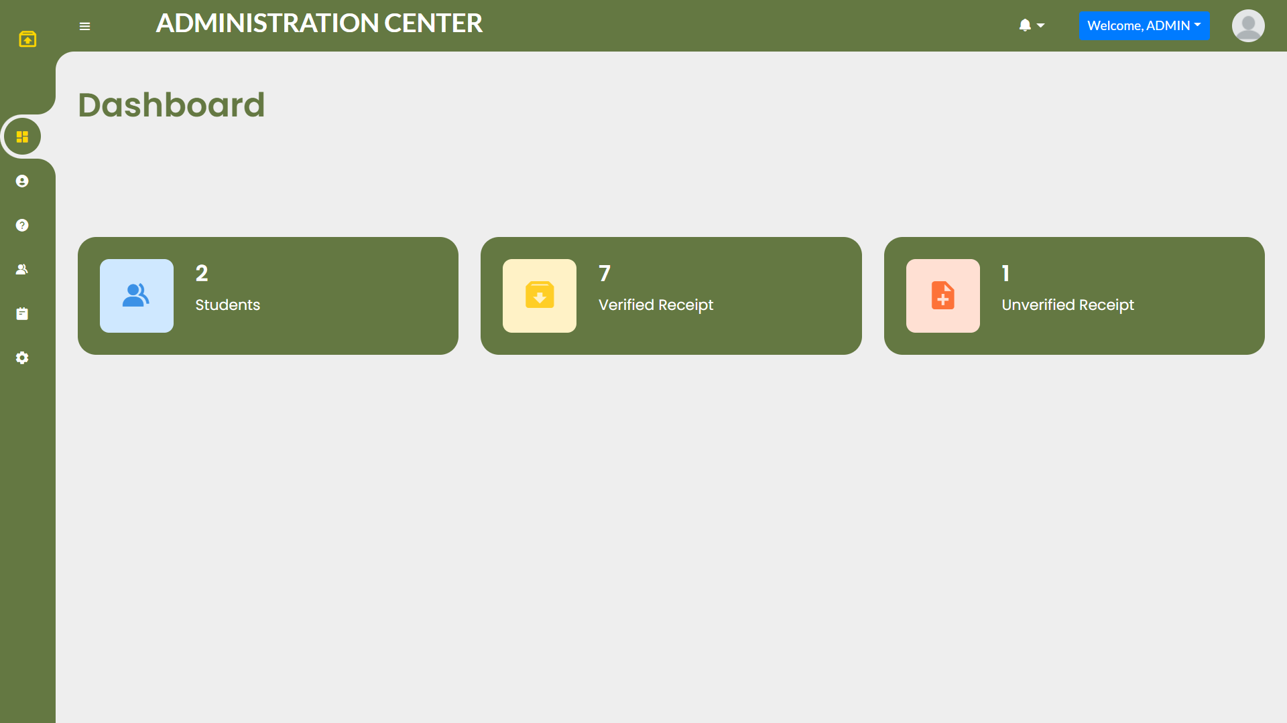

Figure 3.1 – Profile Link

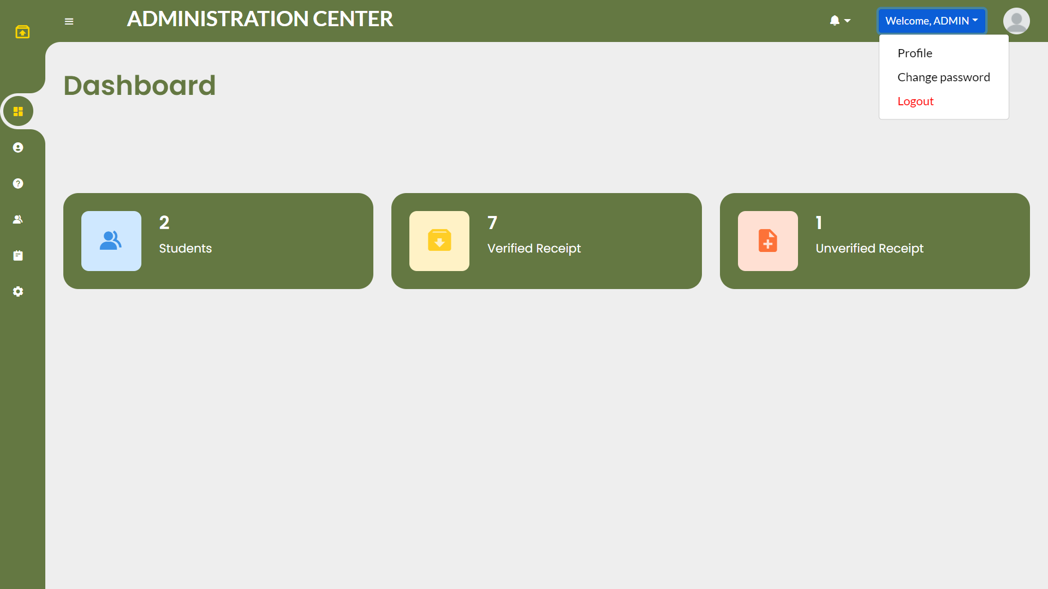

* Go to Profile Page by clicking “Welcome, <User>” as shown in Figure 3.0 & Figure 3.1.

Figure 3.2 – Profile Page

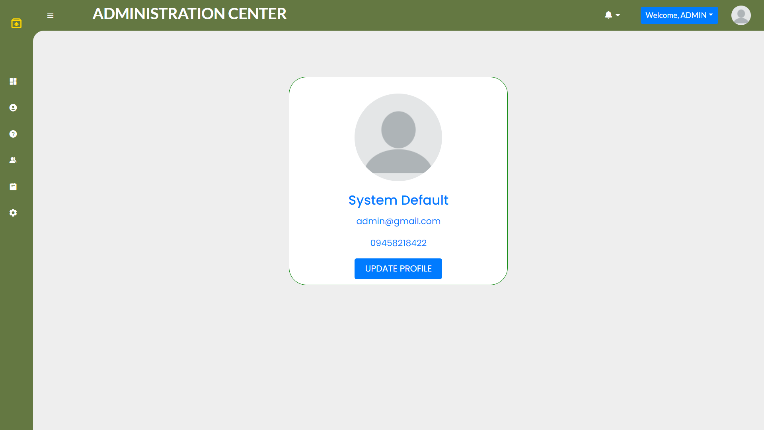

Figure 3.3 – Profile Page

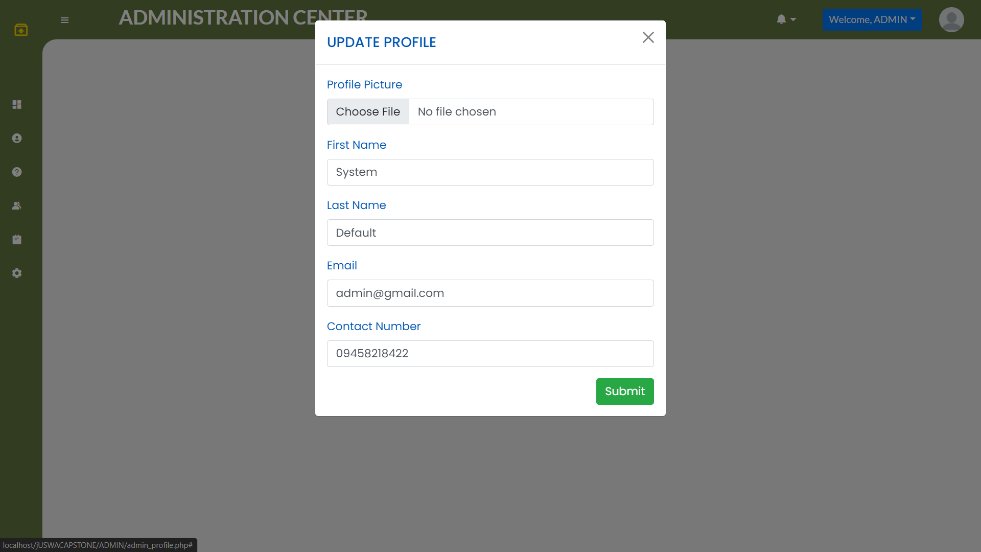

* Click Update Profile and fill in your new desire Information as shown in Figure 3.2 & Figure 3.3.

# **7. Change Admin Password**

* Go to Change Password Page by clicking “Welcome, <User>” as shown in Figure 3.0 & Figure 3.1.

Figure 4.0 – Change Password Page

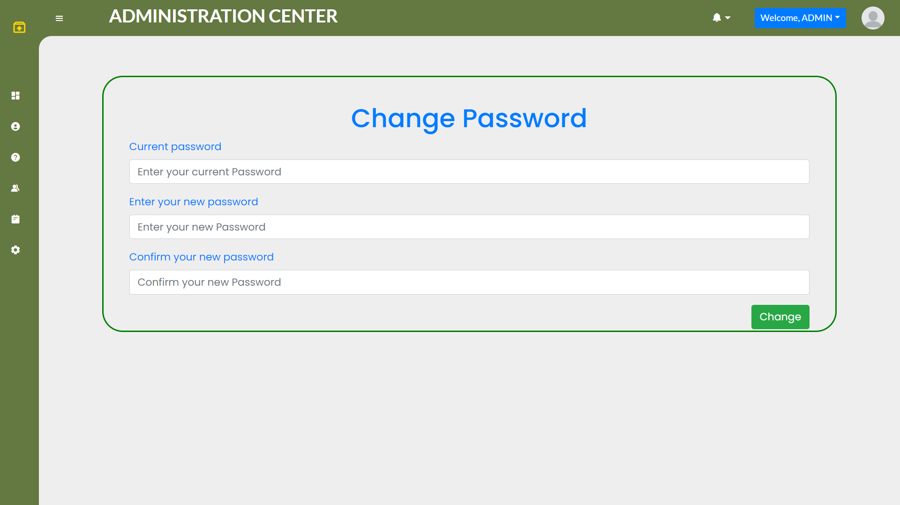

* Enter your current password and new desired password to change as shown in Figure 4.0.

# **8. Create Student Account**

Figure 5.0 – Student Record Page

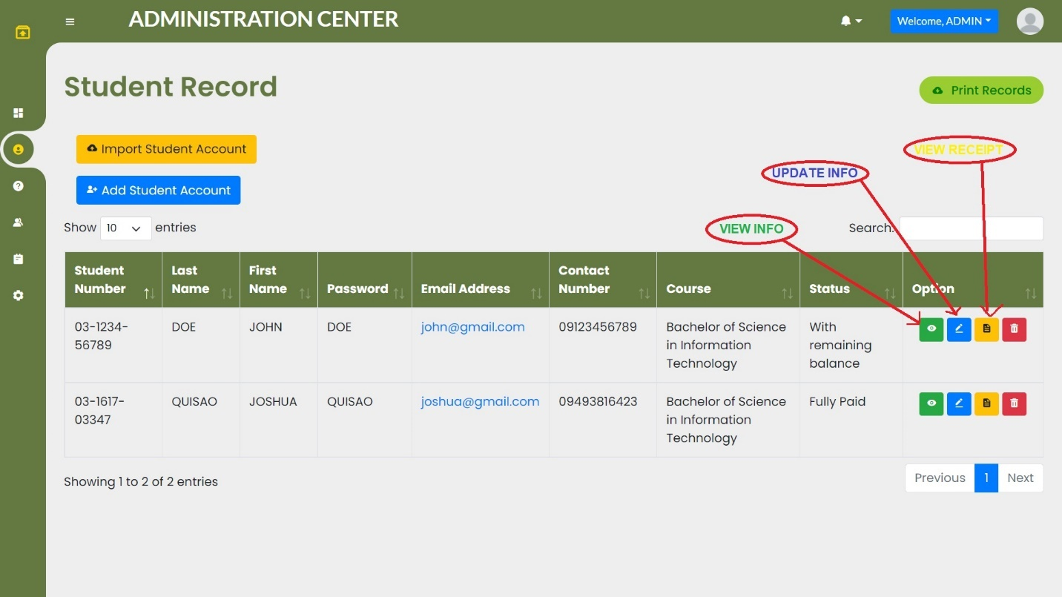

Figure 5.1 – Add Student Modal

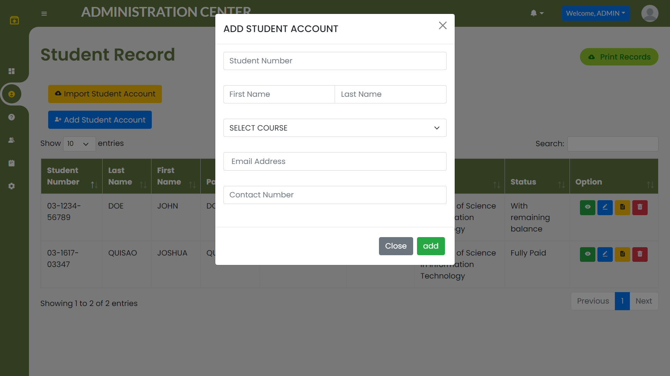

* Click add student account button as in Figure 5.0 and fill in the required information as shown in Figure 5.1.

# **9. Import Student Account**

Figure 5.2 – Import Student Modal

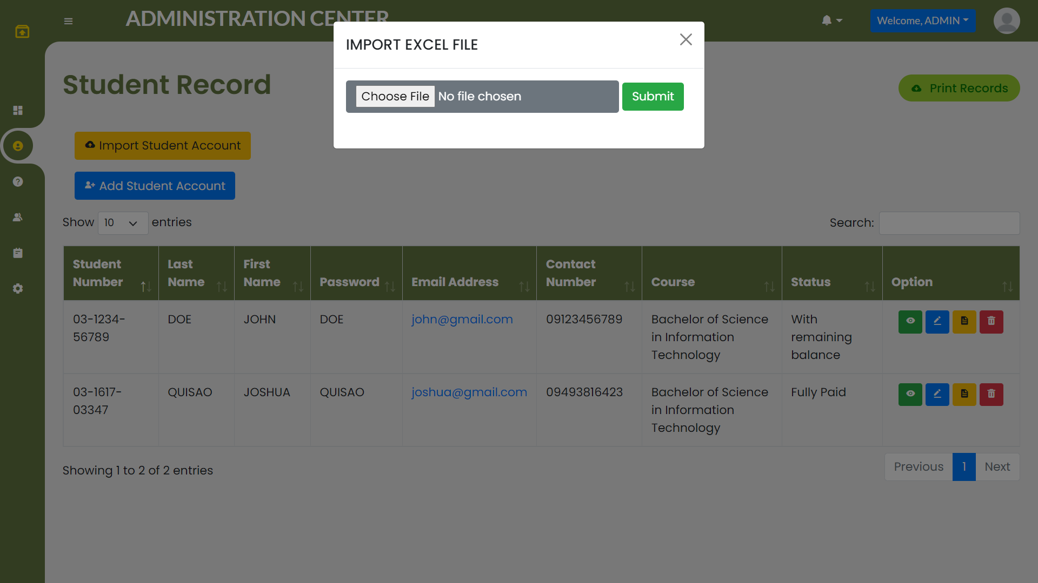

* Click add import student account button as in Figure 5.0 and upload the required Excel File as shown in Figure 5.2.

# **10. Print Student Record**

Figure 5.3 – Print Record Page

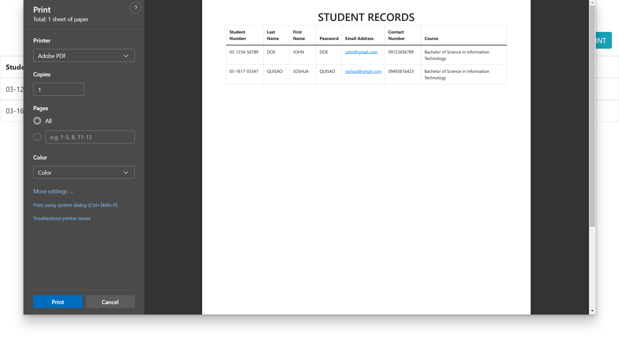

* Click add print records button as in Figure 5.0 and click print as shown in Figure 5.3.

# **11. View Student Info**

Figure 5.4 – Student Info

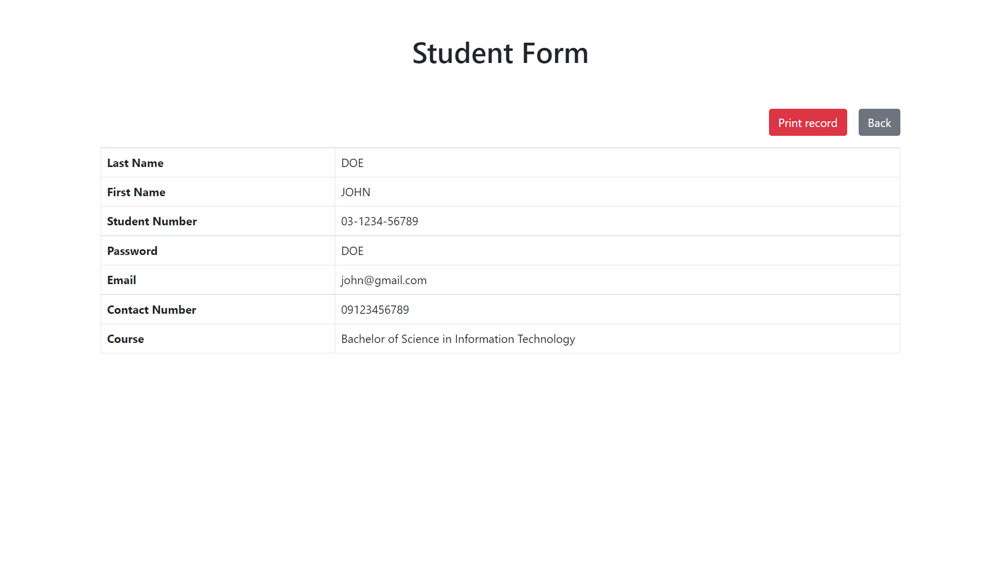

* Click view info button as in Figure 5.0 to view student info as shown in Figure 5.4.

# **12. Update Student Info**

Figure 5.5 – Update Profile

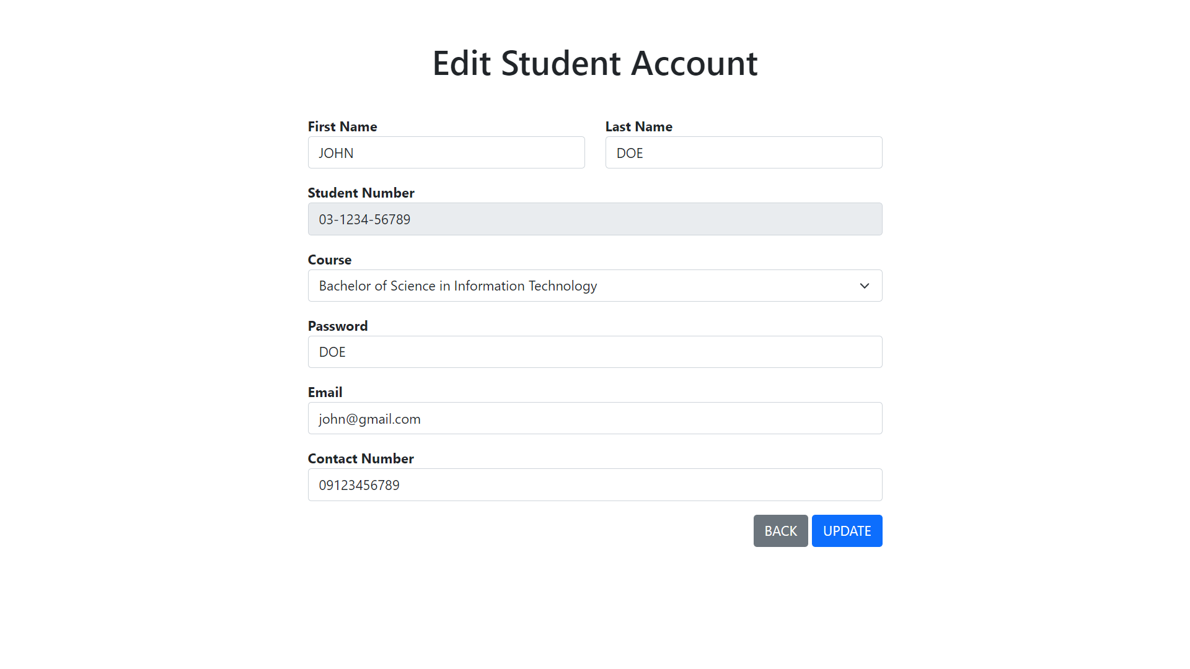

* Click update info button as in Figure 5.0 and fill in new student profile as shown in Figure 5.5.

# **13. View Student Receipt**

Figure 5.6 – Student Receipt List

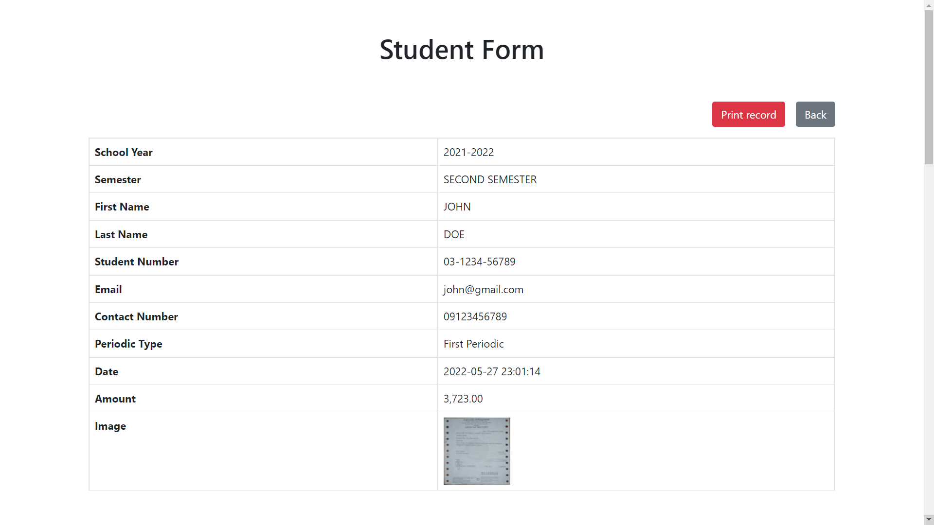

* Click view receipt button as in Figure 5.0 to view student receipt as shown in Figure 5.6.

# **14. Verify Student Receipt**

Figure 6.0 – Request Record Page

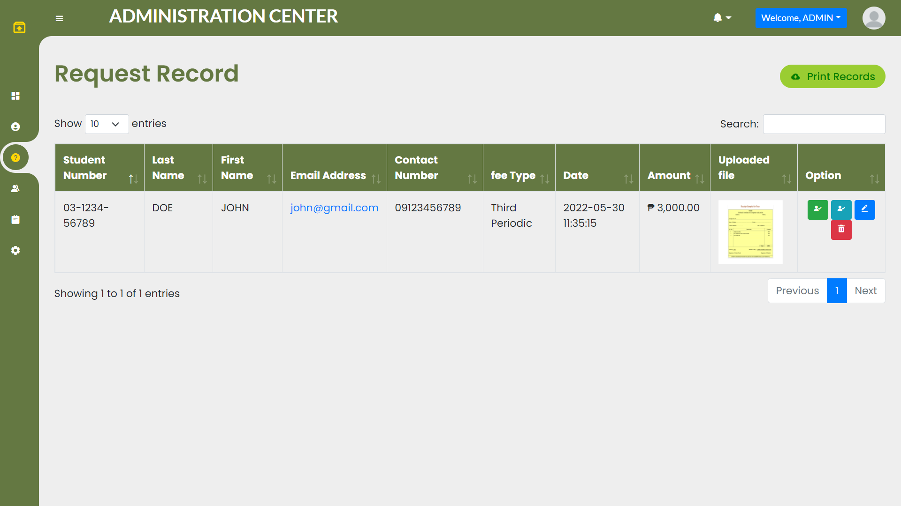

* At the request record page as shown in Figure 6.0.
  + Green button as Verify Full Payment.
  + Cyan button as Verify Partial Payment.
  + Blue button as Edit Receipt.
  + Red Button as Delete Receipt.

# **15. Create Staff Account**

Figure 7.0 – Staff Account Page

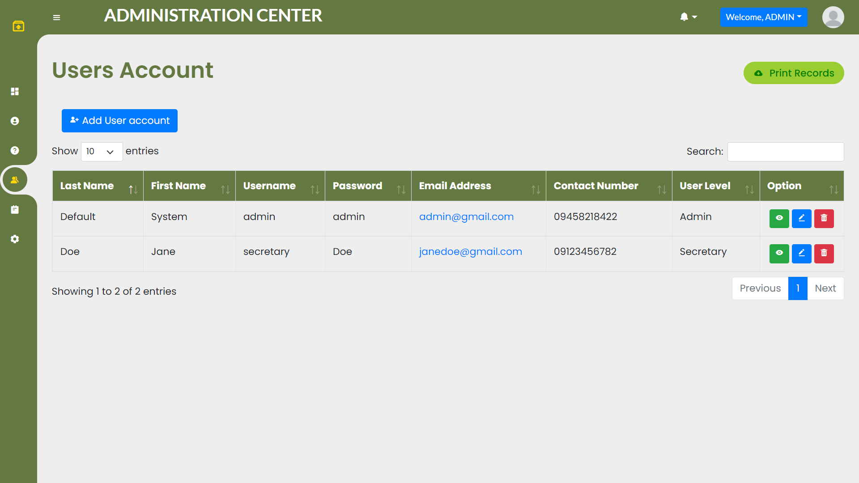

Figure 7.1 – Add User Modal

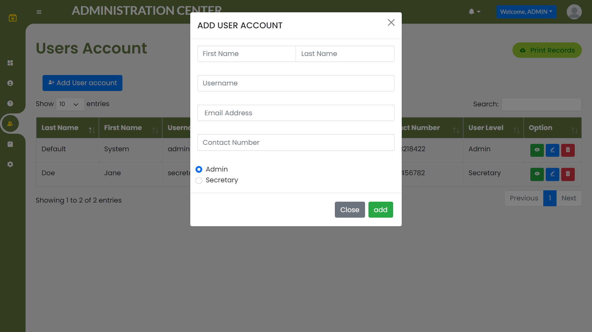

* Click user account button as in Figure 7.0 and fill in required information as shown in Figure 7.1.
  + Admin radio button as Create Admin Account
  + Secretary radio button as Create Secretary Account

# **16. User Logs Section**

Figure 8.0 – User Logs Page

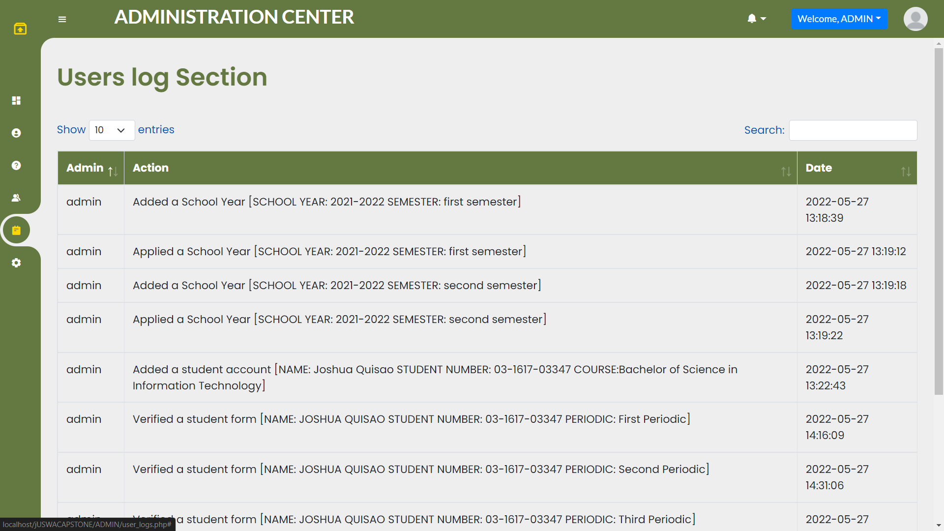

# **17. Create and Set new School Year and Semester**

Figure 9.0 – School Year and Semester Page

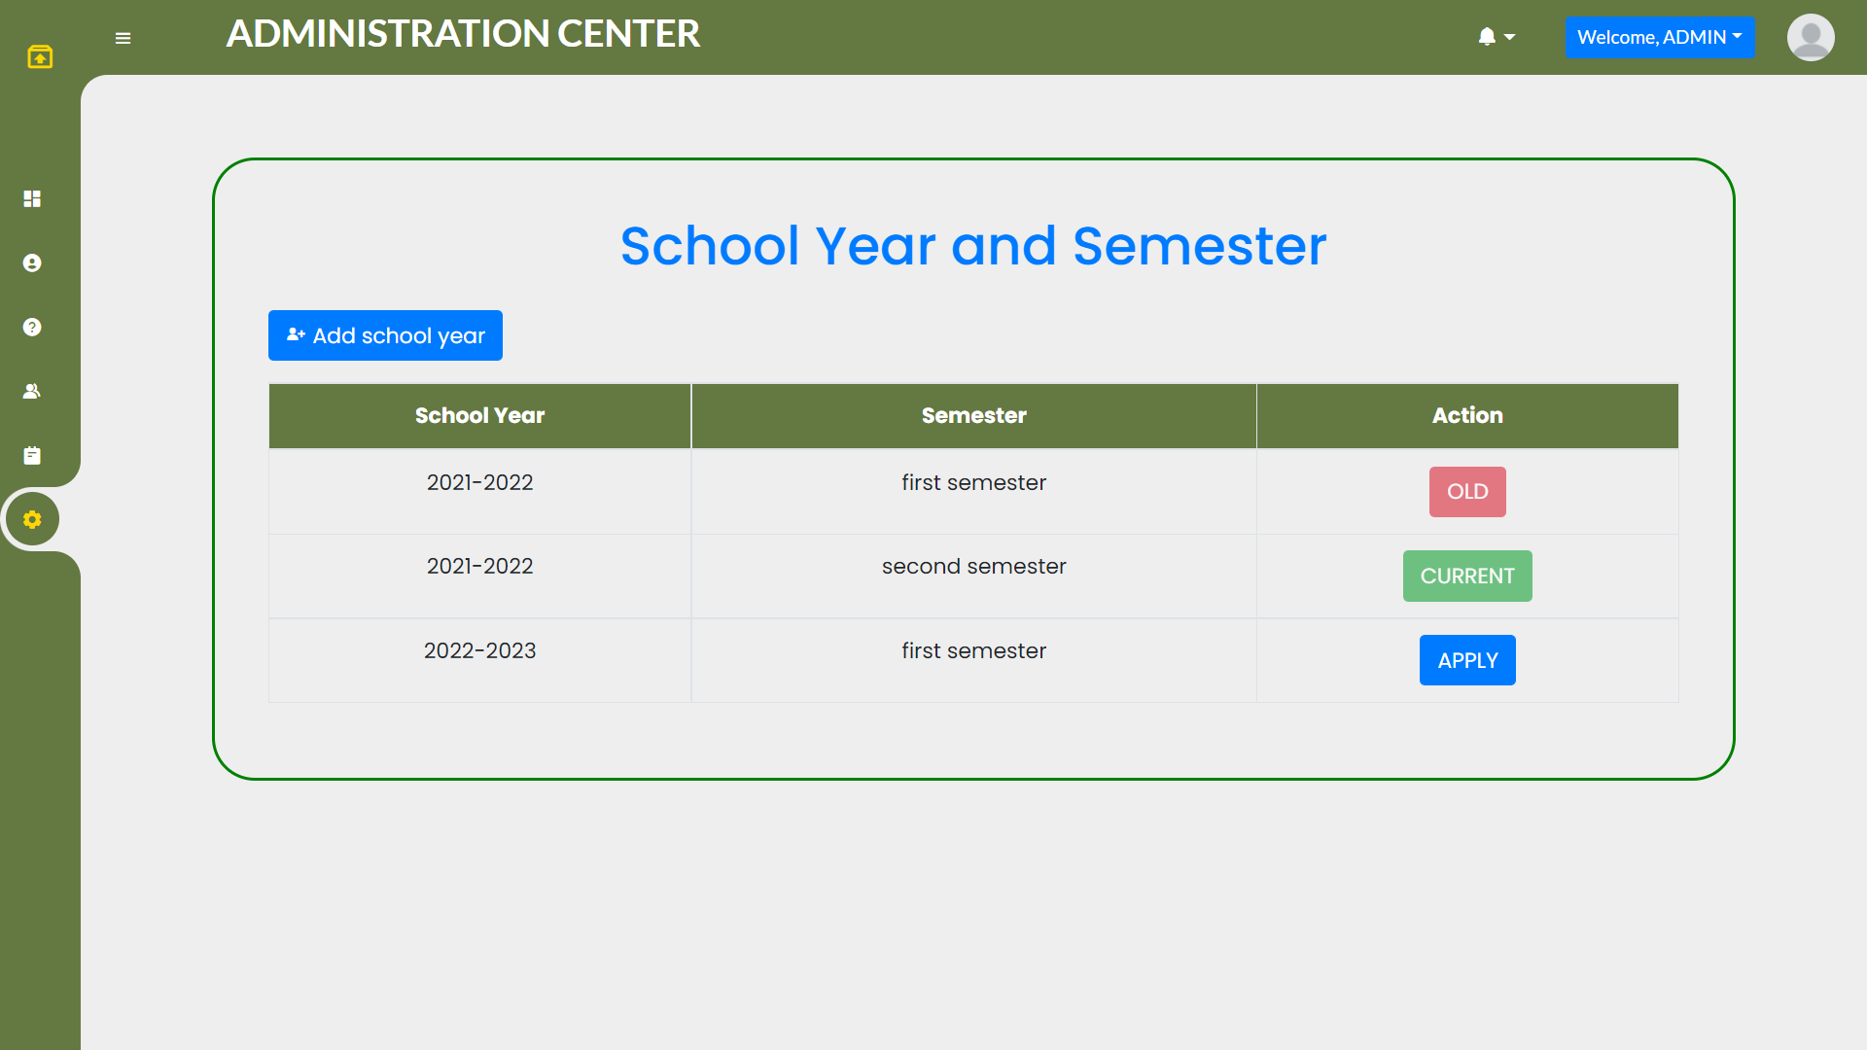

Figure 9.1 – School Year and Semester Page

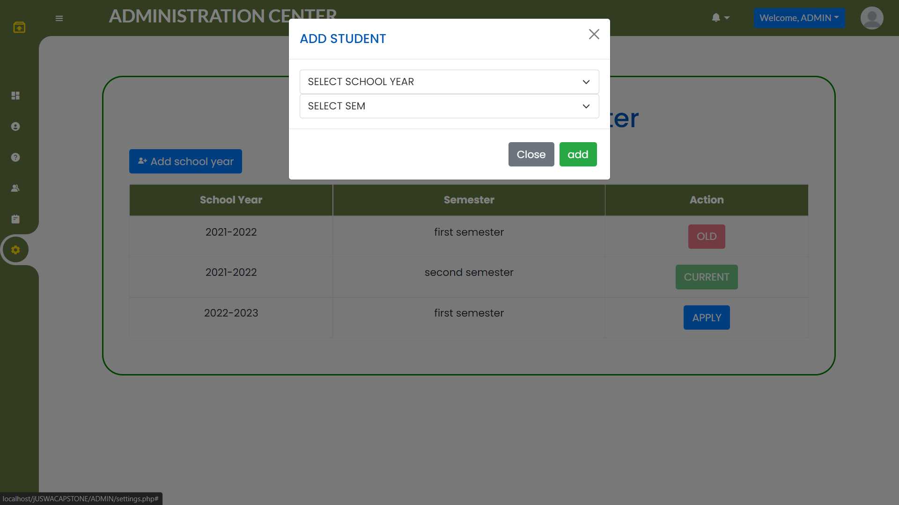

* Click add school year button as in Figure 9.0 and select info as shown in Figure 9.1.
  + Admin radio button as Create Admin Account
  + Secretary radio button as Create Secretary Account
* Click apply button to set new S.Y and Semester as shown in Figure 9.0.

# **System Overview for Student**

The Appointment System enables the Student to perform the following functions:

* Log in using School Given Account
* Update Profile
* Change Password
* View Paid Tuition
* Upload Receipt
* View Payment History

# **Application Access for Student**

1. Open the browser and enter the URL: URL to Application
2. Press enter or Click Go
3. The Home page of the application appears as in Figure 1.1 Index Page

Figure 1.1 – Index Page

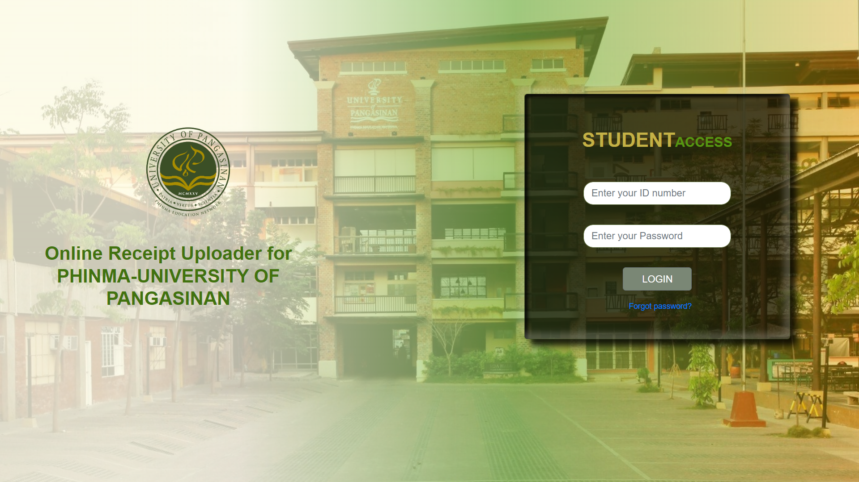

# **4. Student Login**

* Enter the given ID Number and Password by your University as in Figure 1.1.
  + Student Reset password has the same process as Admin Reset Password on Page 4-5

# **5. Update Student Profile**

Figure 2.0 – Dashboard

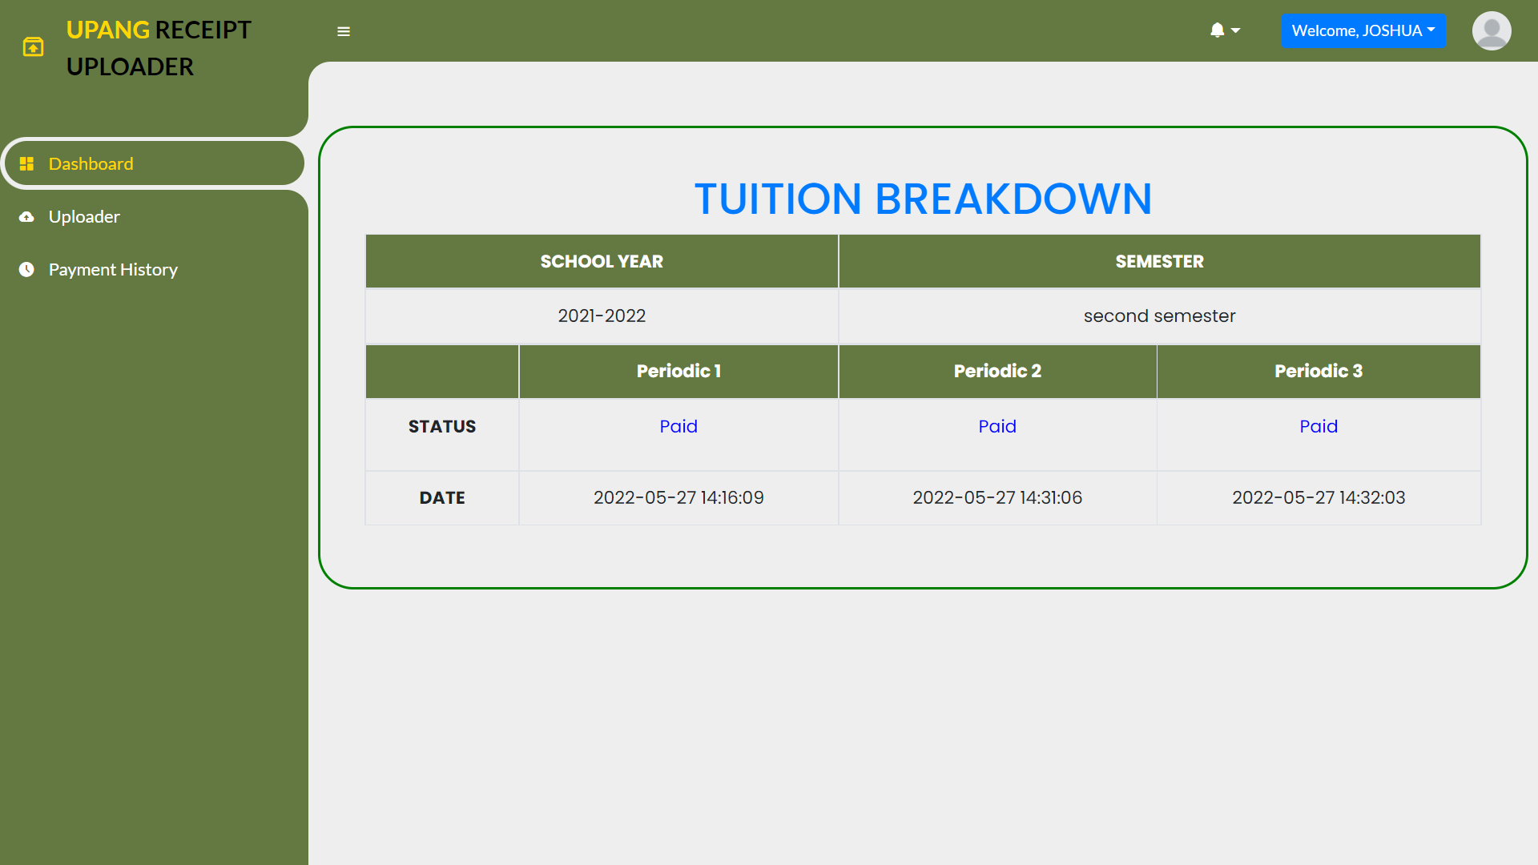

Figure 2.1 – Profile Link

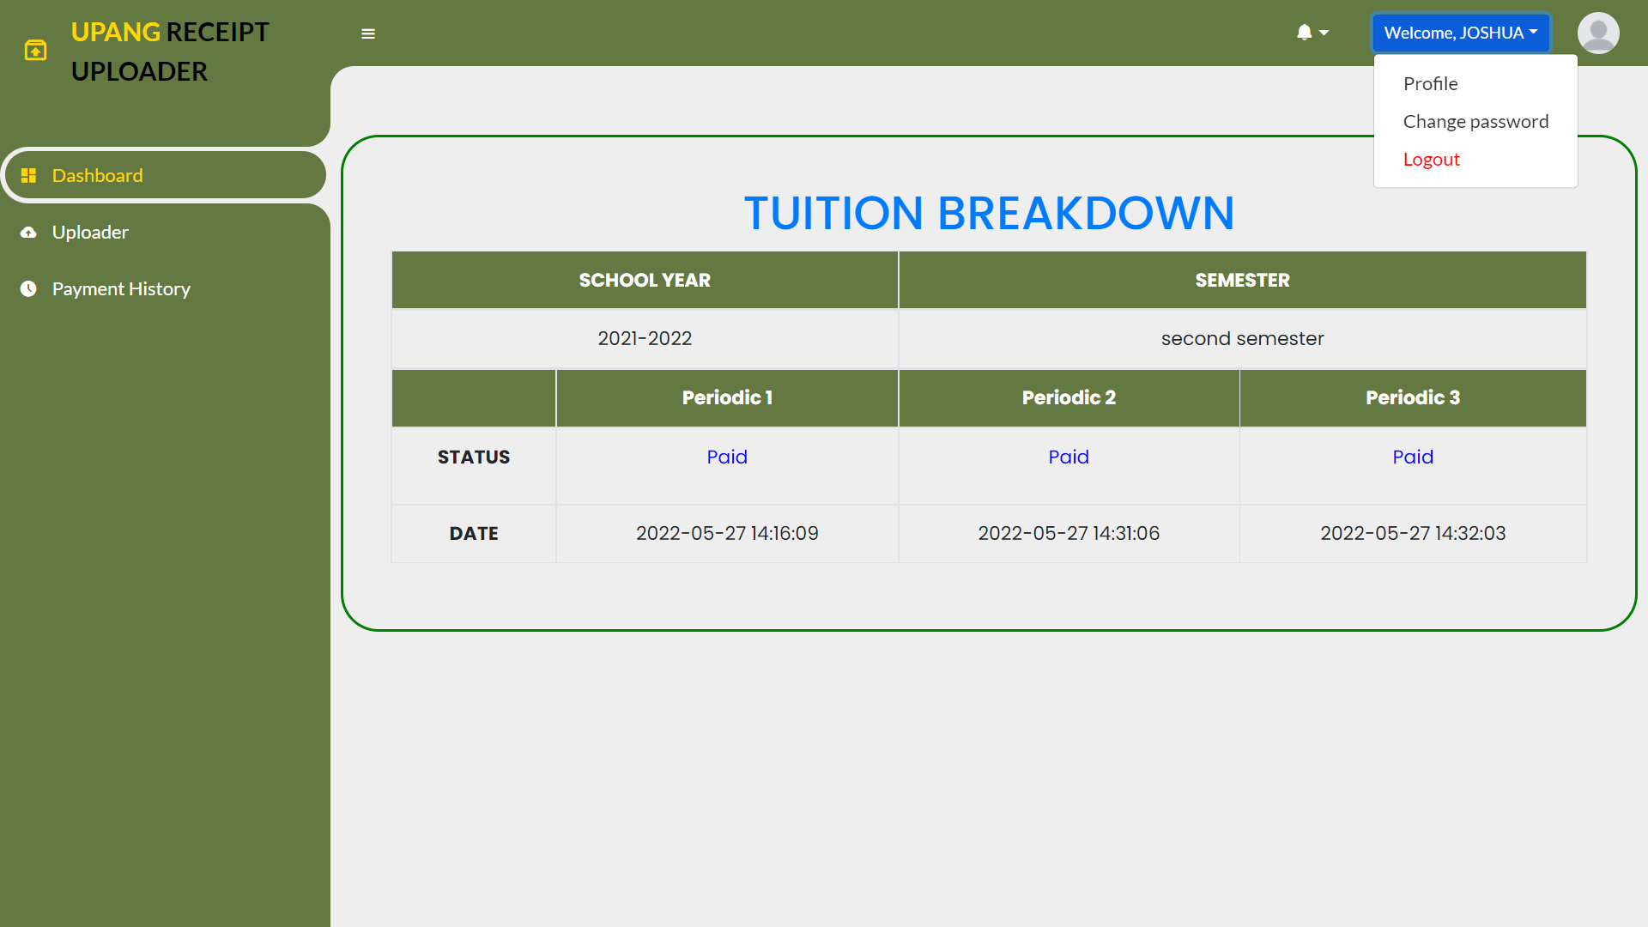

* Go to Profile Page by clicking “Welcome, <User>” as shown in Figure 2.0 & Figure 2.1.

Figure 2.2 – Profile Page

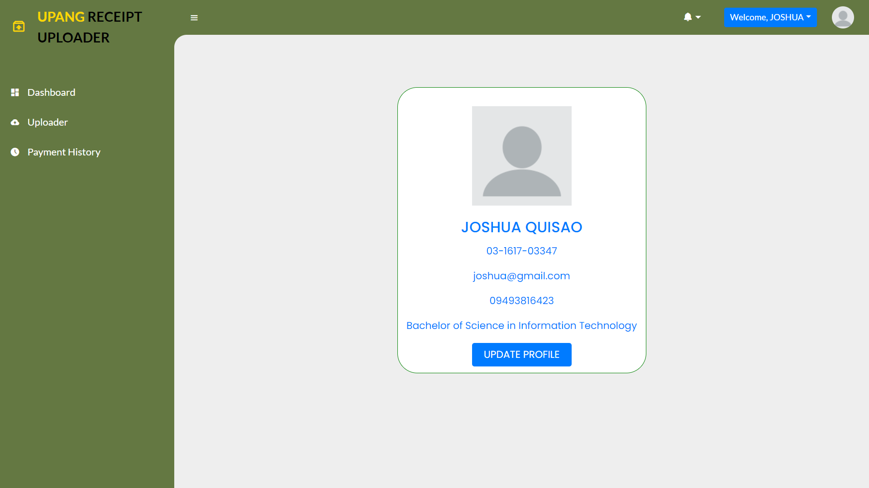

Figure 2.3 – Profile Page

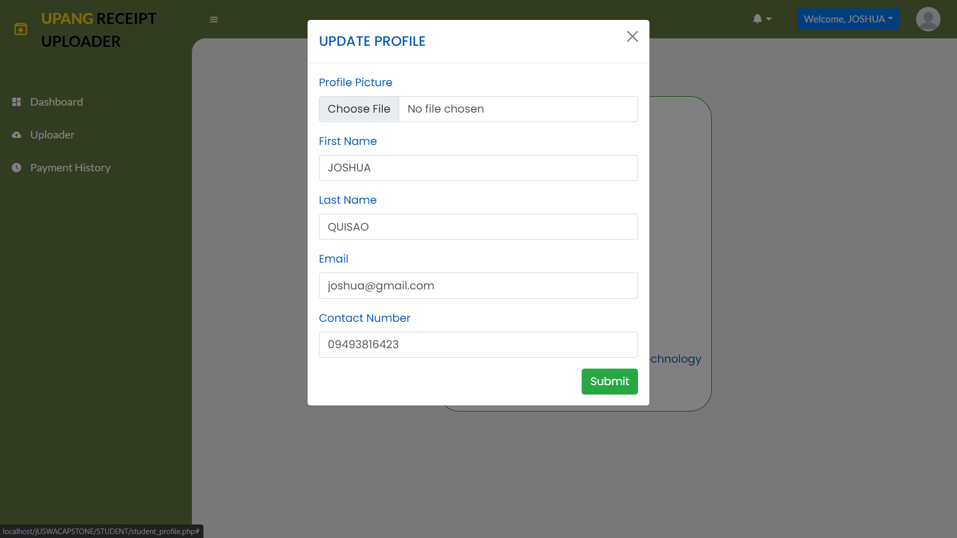

* Click Update Profile and fill in your new desire Information as shown in Figure 2.2 & Figure 2.3.

# **6. Change Student Password**

* Go to Change Password Page by clicking “Welcome, <User>” as shown in Figure 2.0 & Figure 2.1.

Figure 3.0 – Change Password Page

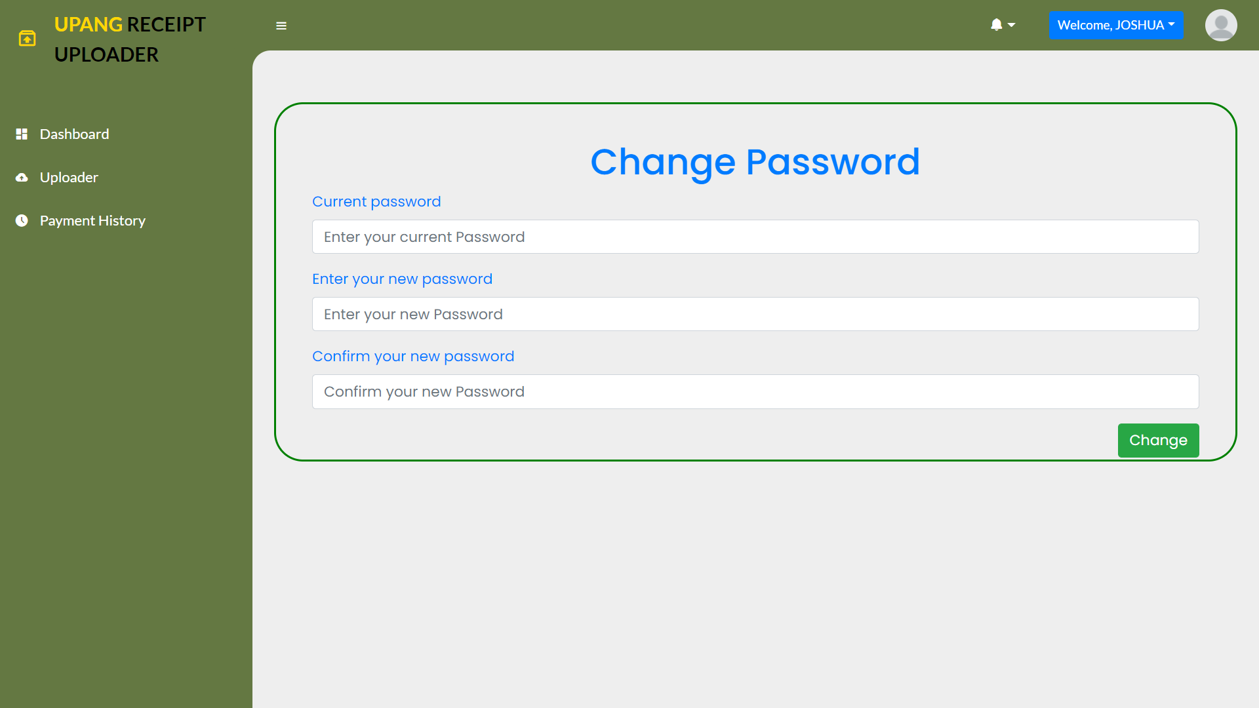

* Enter your current password and new desired password to change as shown in Figure 3.0.

# **7. View Paid Tuition**

* Scan your paid tuition as shown in Figure 2.0.

# **8. Upload Receipt**

Figure 4.0 – Upload Receipt Page

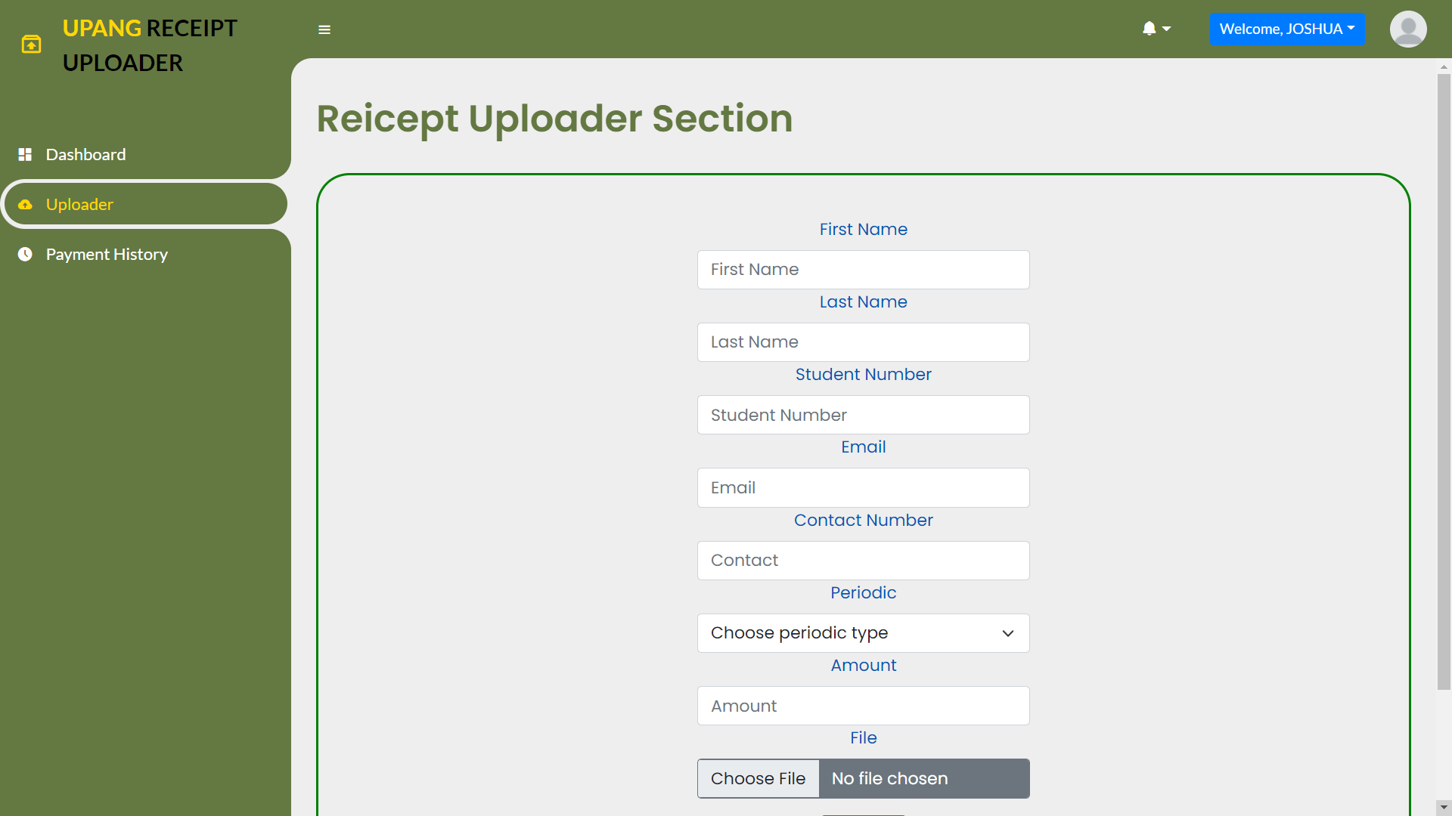

* To upload a receipt, fill in the required information as shown in Figure 4.0.

# **9. Payment History**

Figure 5.0 – Payment History Page

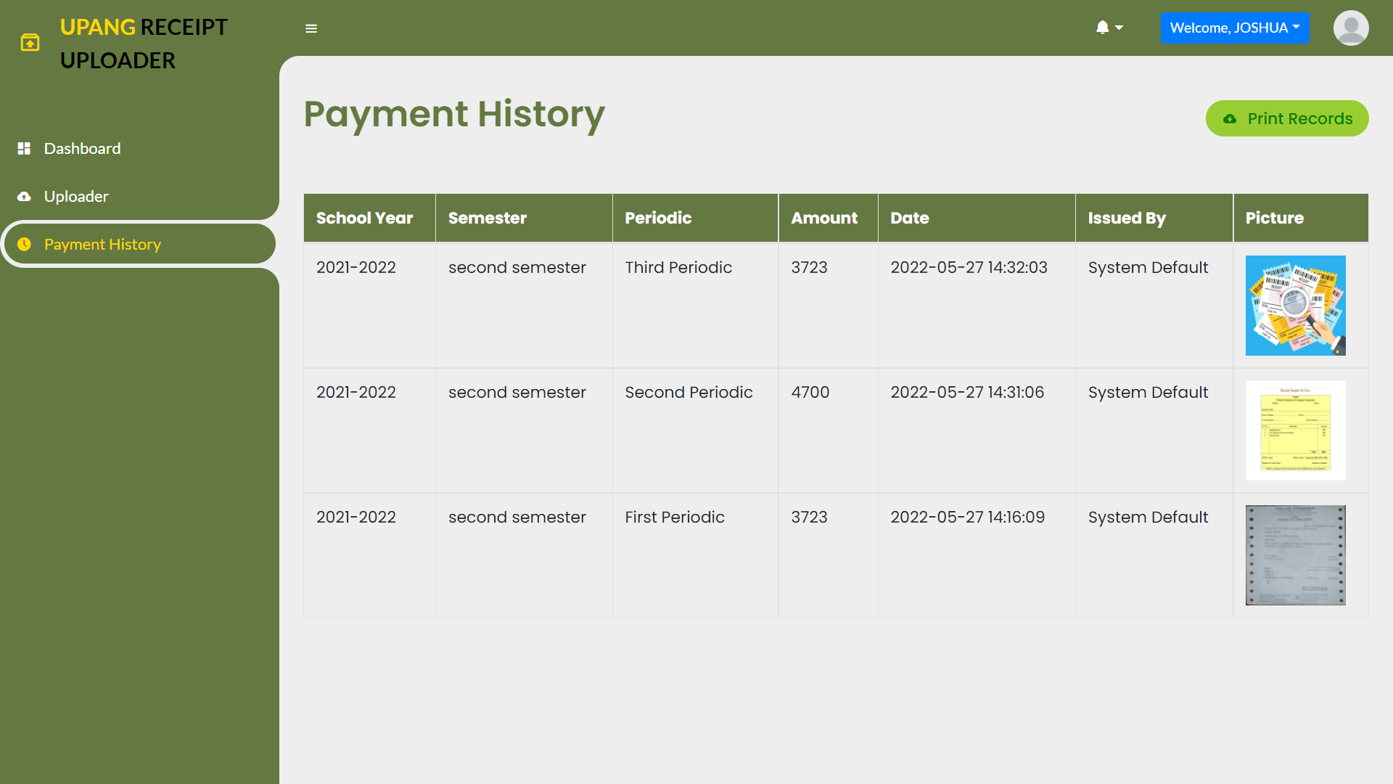

* Scan your submitted receipt as shown in Figure 5.0.
  + Print Records button to print all the receipt submitted.

# **System Overview for Secretary**

The Appointment System enables the Secretary to perform the following functions:

* Log in using School Given Staff Account
* Update Profile
* Change Password
* View Student List with/without permit

# **Application Access for Secretary**

1. Open the browser and enter the URL: URL to Application
2. Press enter or Click Go
3. The Home page of the application appears as in Figure 1.1 Index Page

Figure 1.1 – Index Page

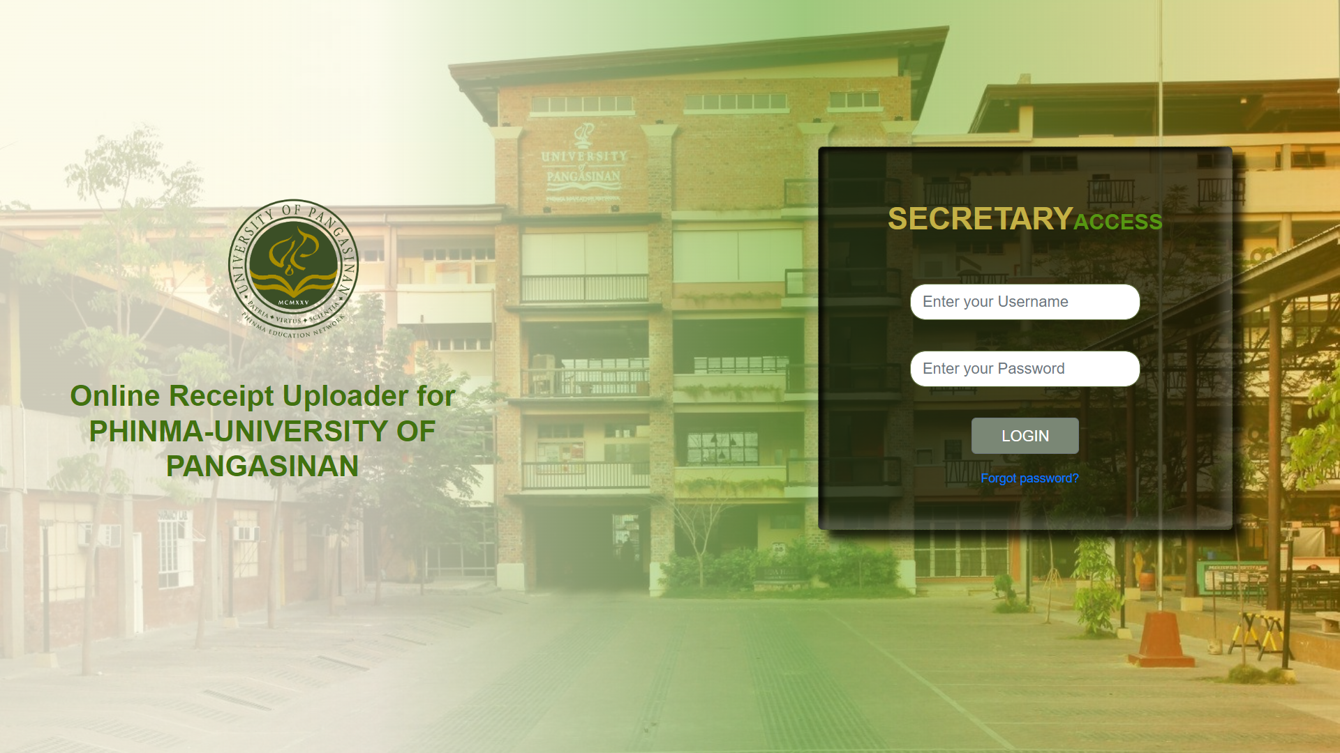

# **4. Secretary Login**

* Enter the given ID Number and Password by your University as in Figure 1.1.
  + Secretary Reset password has the same process as Admin Reset Password on Page 4-5

# **5. Update Secretary Profile**

Figure 2.0 – Dashboard

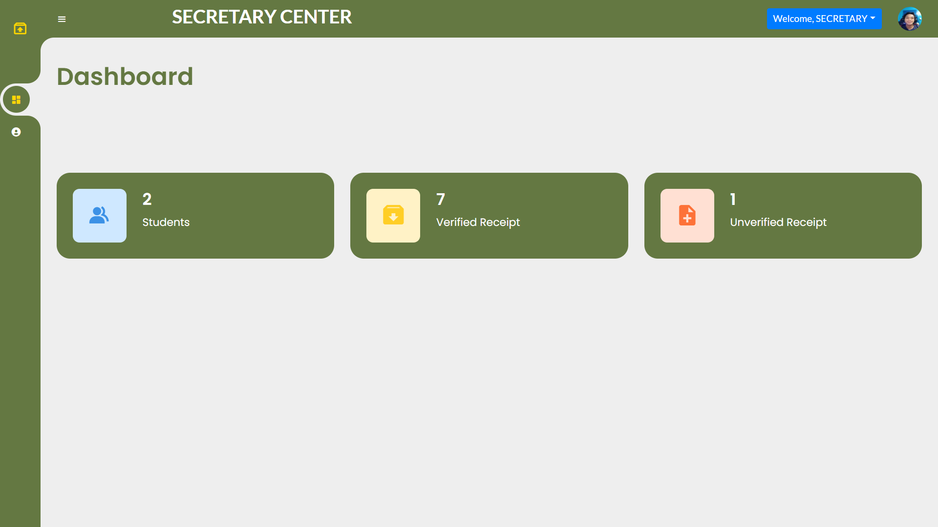

Figure 2.1 – Profile Link

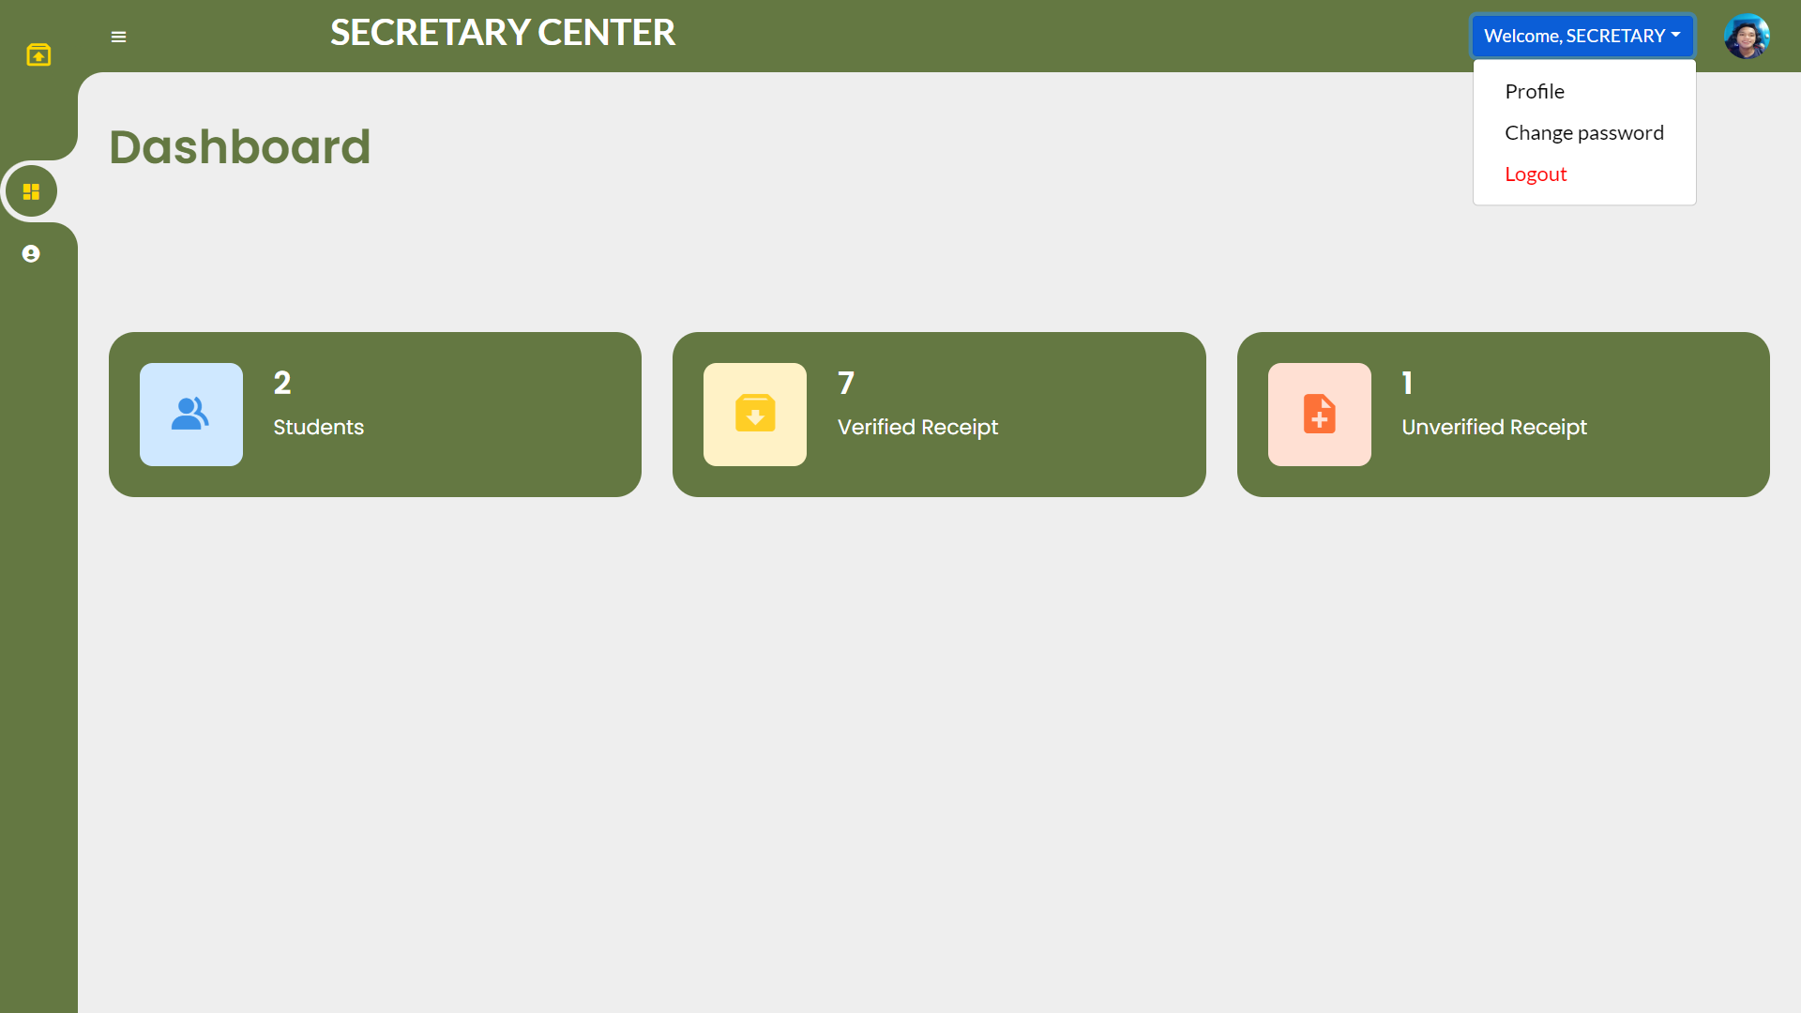

* Go to Profile Page by clicking “Welcome, <User>” as shown in Figure 2.0 & Figure 2.1.

Figure 2.2 – Profile Page

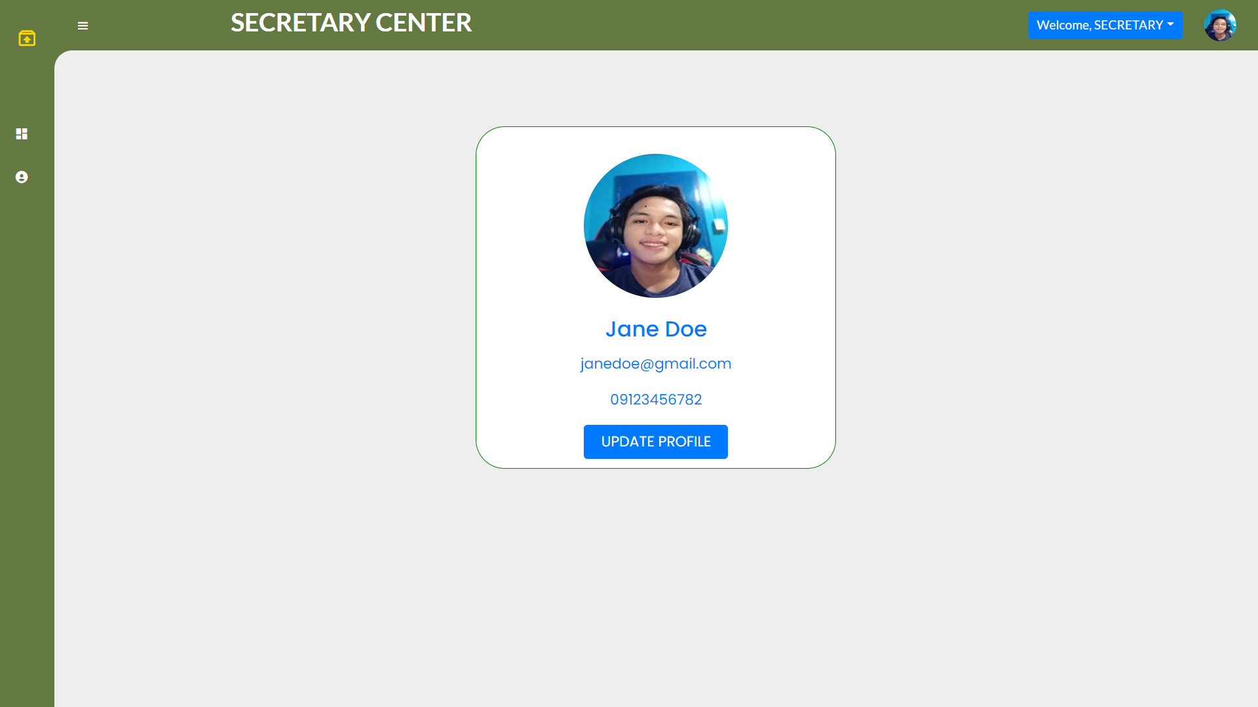

Figure 2.3 – Profile Page

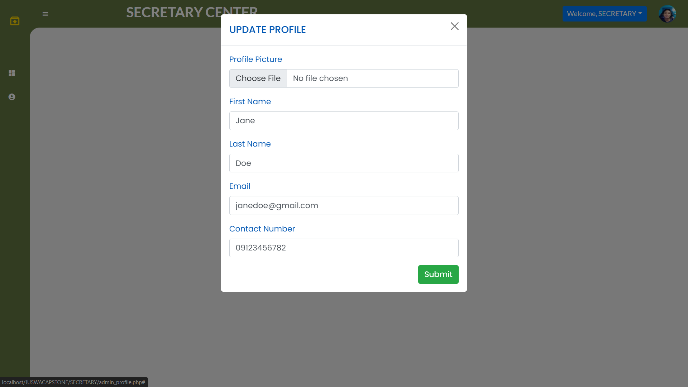

* Click Update Profile and fill in your new desire Information as shown in Figure 2.2 & Figure 2.3.

# **6. Change Secretary Password**

* Go to Change Password Page by clicking “Welcome, <User>” as shown in Figure 2.0 & Figure 2.1.

Figure 3.0 – Change Password Page

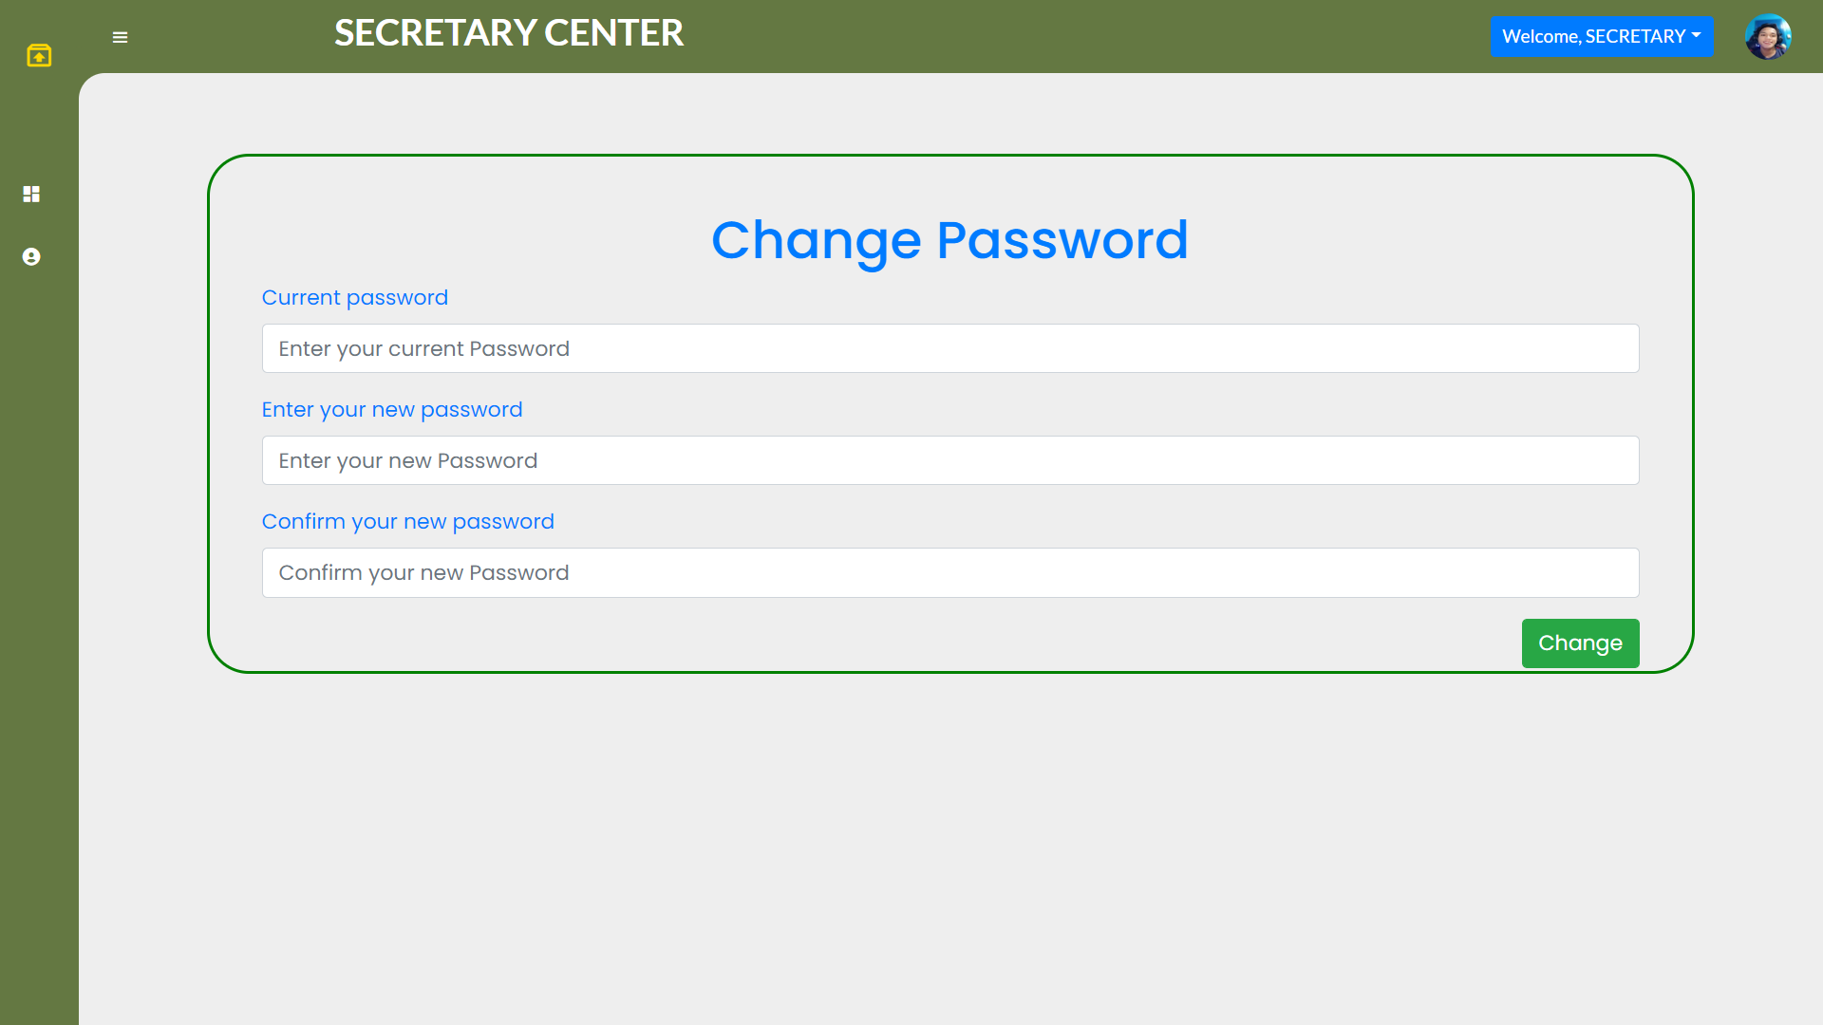

* Enter your current password and new desired password to change as shown in Figure 3.0.

# **7. Student List with/without Permit**

Figure 4.0 – Student Record Page

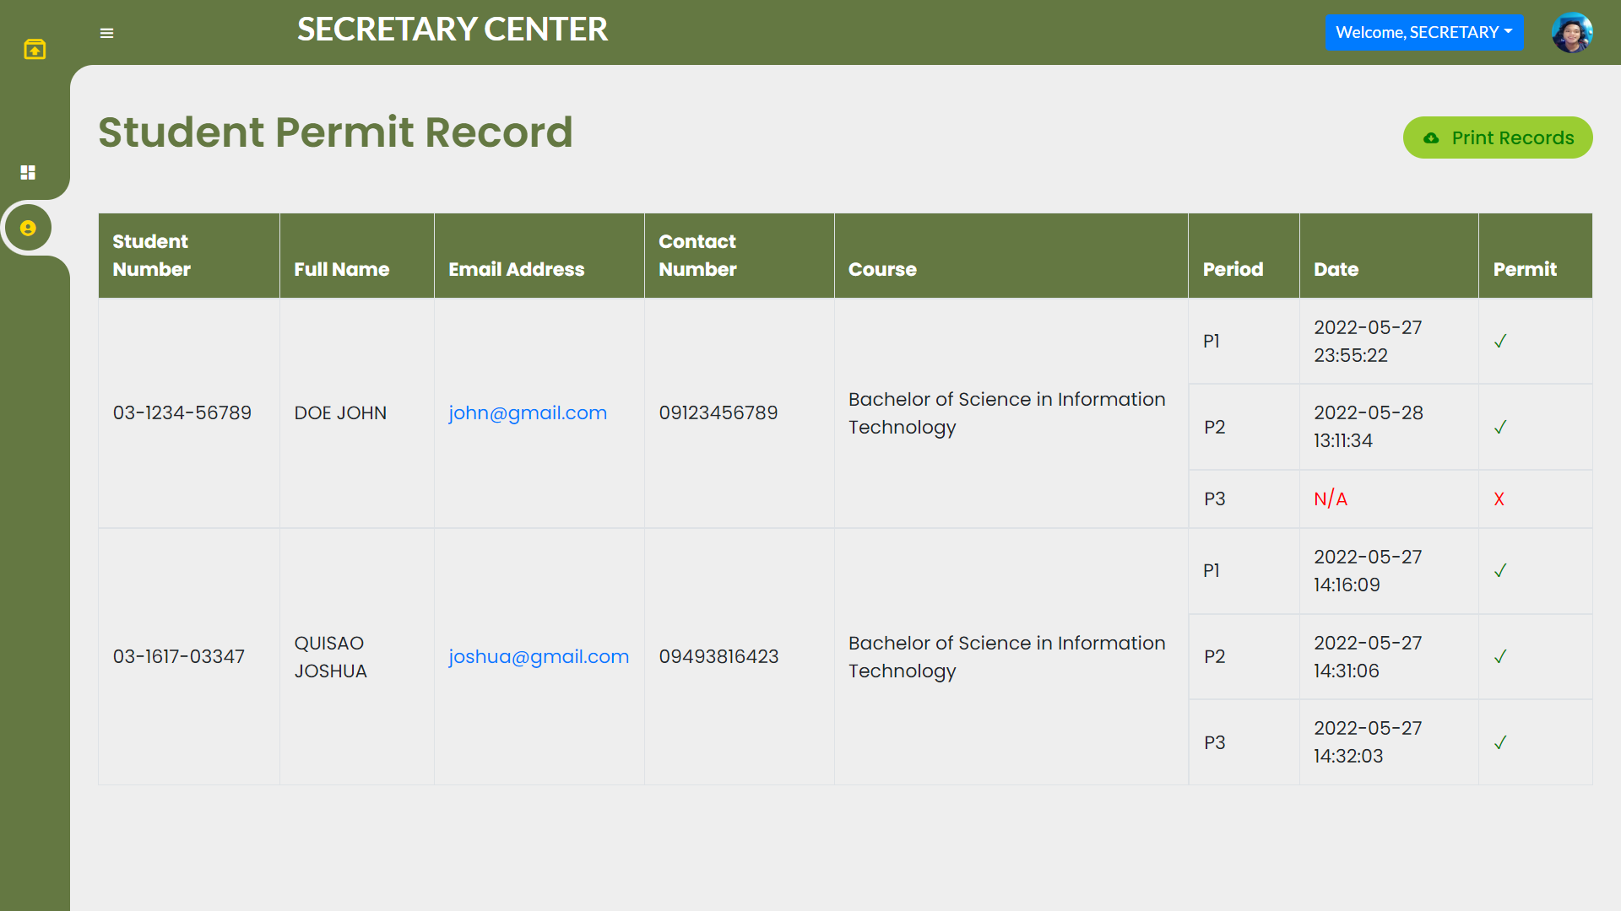

* Scan student has and hasn’t permit as shown in Figure 4.0.
  + Print Records button to print all the receipt submitted.